Objective:

This analysis summarizes key statistics from a placement dataset using mean, median and mode to understand average performance and trends in student placements.

Dataset Columns Analyzed:

Use dataset.describe() in pandas by default gives summary statistics only for numerical (quantitative) columns.
Columns Analyzed:
1. ssc_p: Secondary Education Percentage
2. hsc_p: Higher Secondary Percentage
3. degree_p: Degree Percentage
4. etest_p: Employability Test Percentage
5. mba_p: MBA Percentage
6. salary: Salary offered to the placed candidates

Code to create a table and calculate mean, median and mode:

descriptive = pd.DataFrame(index = ["Mean", "Median", "Mode"], columns = quan)
for columnName in quan:
descriptive.loc["Mean",columnName] = dataset[columnName].mean()
descriptive.loc["Median",columnName] = dataset[columnName].median()
descriptive.loc["Mode",columnName] = dataset[columnName].mode()[0]

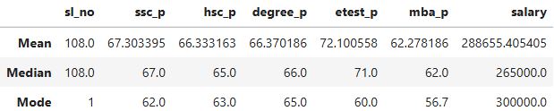

Interpretation:

Mean vs Median:

Most variable show close mean and median values. For example, degree_p has a mean of 66.37 and median of 66.00. If any outlier presents in the dataset or not, median gives the correct middle term. Median omits Outlier.
Mode:

The mode represents the most frequent value. For example, the common salary in the dataset is Rs.300,000. This may suggest a standard package offered by multiple companies.
Conclusion:

These central tendency measures offer a solid first step in understanding student academic profiles and salary trends. The close alignment between mean and median suggests that the data does not contain extreme outliers for most academic scores.

